How to install pygame?

* 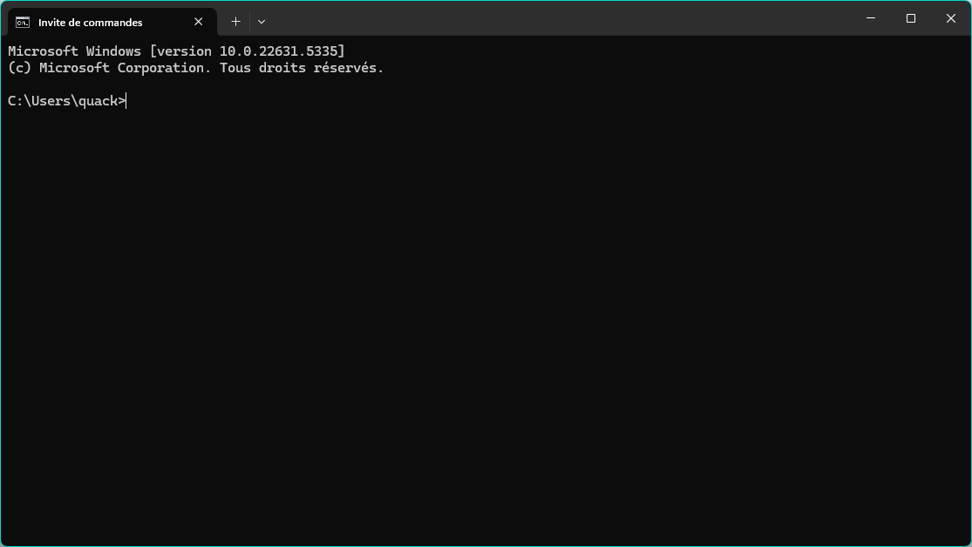Open your command prompt (cmd for windows)
* 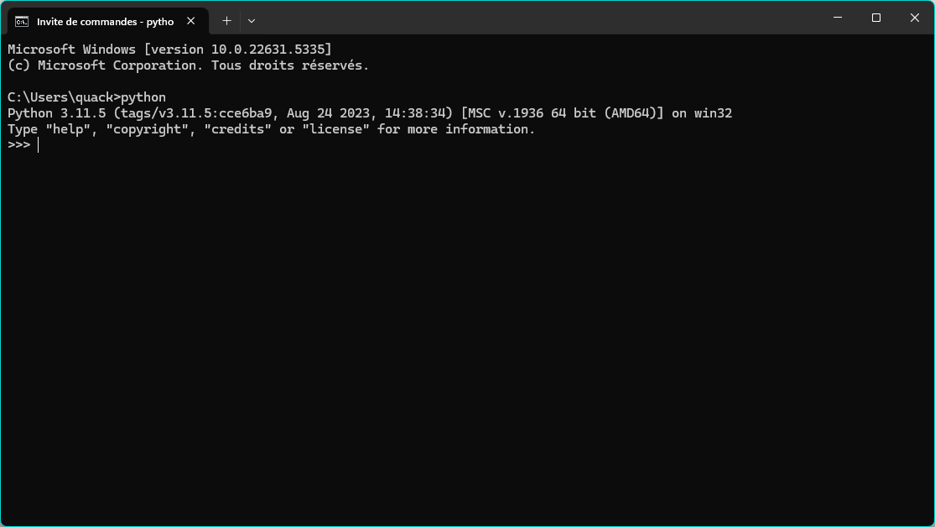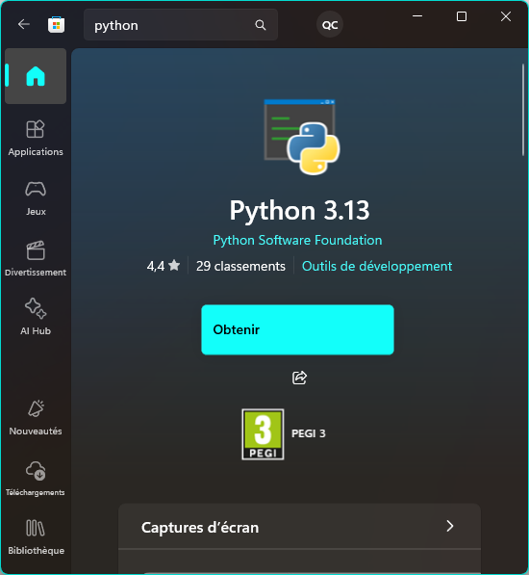Type “python” and install the latest version if you don’t have it yet.   
    
  already install →  
    
    
    
  not install yet →
* 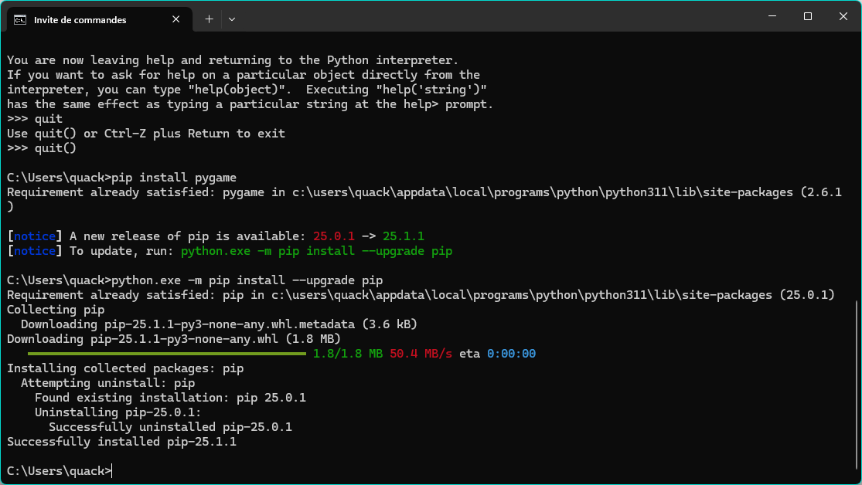Then, type “pip install pygame” (after leaving the python interpreter)
* Finally, you can enjoy the game